List starts off with the number 1,2,3

Push_front()

Push_back()



Pop_front()

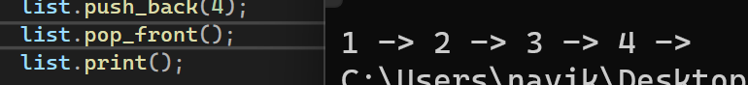

Pop_back()



Front()

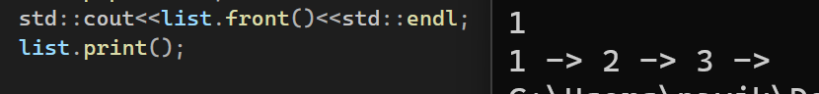

Back()

Empty()

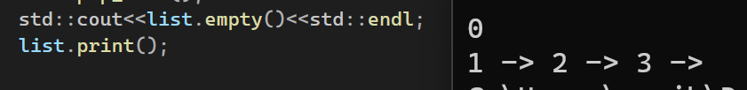

Insert()



Remove()

Find()

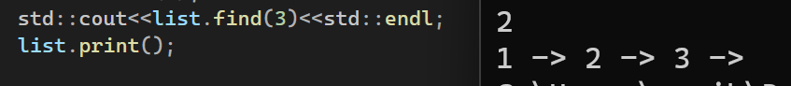

2.

Professional instance called Emily

Nonprofeesional instance called lily

